22 April, 2021

Re: BowlsNSW Unification Ballot
Dear Bowler,

As you may be aware BowlsNSW and WBNSW are considering merging into one entity.

As you are a registered bowler with BowlsNSW you have the right to vote for or against unification. We encourage you to visit www.yambabowlingclub.com.au/bowls and read up on the details of the merger so you can make your informed decision. Alternatively, speak with our Bowls Coordinator Don Freeman for more information.

A Unification Ballot will be conducted starting Friday, 23rd April. Male bowling members will be able to collect their ballot paper and cast their vote according to the timetable below.

Unification Ballot Details:
Voting Area: Club Auditorium
Voting Times: 12noon to 12:45pm and 4:30pm to 5:30pm
Voting Days: Friday 23rd April
Wednesday 28th April
Friday, 30th April
Wednesday, 5th May

The ballot will be counted at 11am in the club auditorium and result announced prior to bowls on Friday, 7th May.

Yours Sincerely,

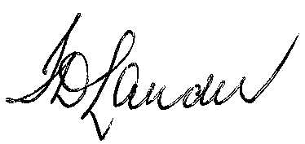

Ian Lauder
Club President

